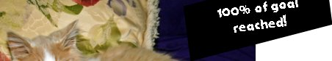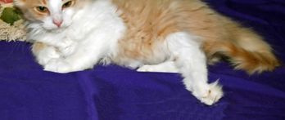
Dobby’s blog: http://www.chipin.com/mypages/edit/id/f8e5049058fff399
Dobby, the little boy with the sweet, sweet personality and the big purr—and big problems made it to Austin for treatment. Thanks to you great angel donors, Dobby went to Animal Trustees of Austin for diagnosis and surgery.
The result—surgery may NOT be necessary, but physical therapy is.
Dobby is “crashing” at Cedar Forest Cat Ranch with Rebecca and John and they are acting as his personal chauffeurs. His initial diagnostic appointment revealed a dislocated right elbow, a dislocated right hip, and a fractured and badly misaligned left pelvis. In addition, he had tendon and nerve damage in his left leg. The doctor recommended amputation of the left rear leg.
However—x-rays were taken to verify the course of treatment. Then a waiting period. Then more x-rays. Rebecca and John were beginning to wonder what was going on. What was happening was a dilemma. If Dobby’s left rear leg were amputated, he’d have to heal with his weight on his right side, with the two dislocations. If the right side dislocations were rebroken and set, he’d be putting his weight on the side where he had NO deep muscle pain in his damaged left leg.
More x-rays. And then, the technicians said that Dobby seemed uncomfortable during his x-ray. Back to the exam table. Dobby’s nerve damage was finally healing. He needs extensive physical therapy, but at least for now, no amputation, no rebreaking, no surgery.
Little Dobby will be chauffeured to his PT appointments by John and Rebecca, and we hope that his tendons and nerves will heal enough that he can use the leg normally. If so, he may never need surgery on his fractured leg. The two dislocations have healed, and although he doesn’t have full range of motion on that side, he can get along fine and walk and run. It’s the left rear leg that is worrisome today.
Thanks to all of you who have donated, physical therapy is within Dobby’s reach, and this little boy with the big purr will be able to have a chance at normal range of movement, at least on one side of his little broken body.
The first phase of his physical therapy starts next week. Watch Dobby’s ChipIn page for updates, or email Mickey@domecats.com.
Thank you so much for caring about this tiny boy. Cross your paws for his future.
NOTE: The photo below is digitally painted by Bari DuBois of www.cathappy.net
