The tempo of their time

A leader says anyone can melt into a drum circle and discover its rhythm.
By RITA FARLOW, Times Staff Writer
Published February 6, 2008

Participants of all ages bring a drum or other percussion instrument to the drum circle on Saturday at McGough Nature Park. Listeners of all ages are invited to relax by the campfire and enjoy the rhythms led by Barry Skeete, who brings extra drums. Many have never played a drum before. | 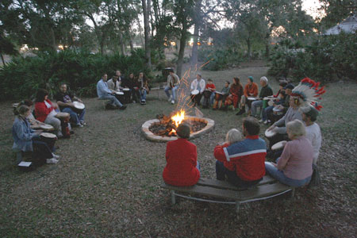
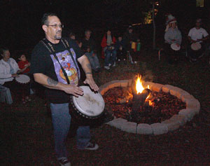 | Barry Skeete leads the circle in traditional drumming songs. A drummer since age 9, Skeete was certified last fall as a drum circle facilitator by Village Music Circles.
The last rays of light were fading fast from the sky Saturday evening. - The bonfire crackled and the extra drums were passed out. - It was time to jam. - "Let your inhibitions go. Don't worry about how you sound," Barry Skeete said.
Skeete, who leads the fire and drum circle at McGough Nature Park, gave a short lesson on creating bass and tone sounds before launching into what he calls the "hello" song. The 30 or so participants joined in the collaborative percussion effort, where drummers shake hands during pauses in the rhythm.
The group ranged from preschoolers to senior citizens, and nearly all said they had never played the drums.
Within two songs, the inexperienced percussionists were beating on African drums, shaking maracas and rattling tambourines with abandon.
"At least 75 percent say, 'I've never played a drum and I have no rhythm,' and I'll say 'You've never played a drum, that's true, but you say you don't have rhythm and I'm going to prove you wrong there,'" Skeete said. "My goal is to just show people what type of ability they have inside them."
A drummer since age 9, Skeete was certified last fall as a drum circle facilitator by Village Music Circles. VMC was founded by Arthur Hull, considered by many the father of drum circle movement.
The overall purpose of a drum circle is to create original music while working with those around you, Skeete said. It's about enjoying music together and connecting to your fellow participants, he said.
George Noel, 58, of Dunedin, brought his bodhran - an Irish handheld drum - after seeing a sign announcing the drum circle, which is held once a month from January to April.
Noel said he felt a synergy with the group. "You're feeding into something bigger than yourself," Noel said.
Drum circles are freeing, Skeete said, because people become unhitched from their normal roles, routines and expectations.
"All of that goes away while you're drumming," he said.
"There's no race, no religion, no political views. It's all about playing and having a good time, and you become one for that period of time."
Because you can keep the beat on just about anything - sticks, rocks, your own hands and feet - percussion is the great equalizer, Skeete said.
"If you don't have a lot of money, you can still make something that you can play with. You don't need $500 to participate," he said.
Skeete said he always brings extra drums that he's happy to lend. But if you're going to sit in on the circle, he would like you to join in.
You might have more fun than you bargained for, he said.
"I hope they get refreshed," he said. "I hope that they realize they have way more potential than they knew they had, and that they realize that they do, in fact, have rhythm."
Rita Farlow can be reached at farlow@sptimes.com or 727 445-4162.
To learn more: Contact Barry Skeete at (727) 235-7228 or visit www.drumwithme.com or www.bluejayrhythms.com
If you go: The fire and drum circle meets at 6 p.m. the first Saturday of the month, January through April, at McGough Nature Park, 11901 146th St. N, Largo. For information, call 518-3047.
Barry Skeete facilitates drum circles for corporate retreats, senior centers, schools and other events. For information, visit his Web page www.drumwithme.com.

