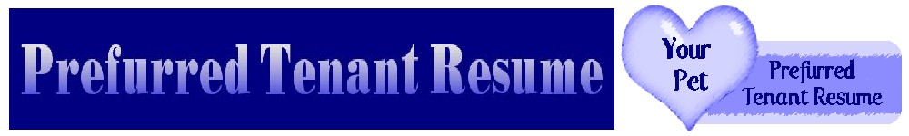
September 11, 2008 For Immediate Release
CALGARY HOUSING CRUNCH LEAVES PET OWNERS HEARTBROKEN
Solution sought for increased dumping of pets as landlords tighten rules; Humane Societies report increased surrenders due to more no-pet housing
The tremendous increase in the demand for housing caused by Alberta’s boom has meant more pets are being surrendered to the Calgary Humane Society and other shelters due to the growing number of no-pet apartments, condos and other rental accommodation. Pet owners must choose between having a place to live or surrendering their beloved, and often only, companion. The result: overcrowding in shelters due to the lack of pet-friendly homes. In an attempt to encourage more housing for pets in Calgary and area, a pet resume service called Prefurred Tenant Resume has been created.
“Our staff frequently see people in tears and very distressed over being forced into this choice,” says Patricia Cameron, Executive Director of the Calgary Humane Society (CHS). “We also see animals who pine for their owners. Even when they are adopted, the shattering of this bond can break their hearts.”
"In 2007, 25% of owner surrendered animals were due to moving or no-pet housing,” adds Cheryl Wallach, General Manager of the CHS.” This is an increase – it was 17% in 2004."
Andrea J. Lee is the Marketing & Grants Coordinator for the Cochrane & Area Humane Society. She talks about the same situation happening outside of Calgary. “It is devastating to both pet and guardian when the reason for surrender is lack of pet-friendly housing, it just seems so unnecessary. Keeping pets and their guardians together not only benefits the pet and guardian, it eases the burden on animal shelters and their staff and volunteers who have to try to find loving homes for all of these animals and sometimes make tough decisions when they can't.”
Owning pets is not frivolous; scientific studies from such institutions as the State University of New York at Buffalo and the National Institute of Health Technology (U.S.A.) prove that pets lower blood pressure, relieve stress, prevent recurrence or even onset of heart attacks, provide greater psychological stability, and ease depression and anxiety for their owners. These benefits are derived from everyday pets; specially trained Service Animals go above and beyond, give formerly housebound people new freedom.
Ontario is currently the only province with a law prohibiting discrimination against prospective tenants who own pets; nor can pets alone be cause for eviction if they are causing no problem. Other provinces, including Alberta, are following suit. Pet ownership requires a high level of commitment and responsibility. The best tenants are those who are reliable dedicated pet owners who truly value the chance to have housing that accommodates their loved pets.
For Candace Carnie, the idea for the pet resumes came to her following a visit to the Cochrane and Area Humane Society.
“I asked about two cats I had seen on their website,” she reports. “The receptionist told me that they didn’t ‘make it’ – meaning they had been euthanized. She said sadly, ‘We’re so full.’ I walked into the cat room, tears streaming down my face, wishing I had a big house to foster them all. I was sick and tired of the situation. I knew I couldn’t fix everything – but I had to do something.”
A friend helped with research, and a tenancy resume service for pets became a reality. Candace knew of people who had used such resumes and found homes for themselves and their pets, even when a rental ad said “no pets”. The September 2008 issue of Cat Fancy magazine has a feature on finding a pet-friendly apartment and says this: "You might find that some rental properties require a pet resume that includes references from previous rental managers."
“As a service, we can offer independently verified pet references for landlords,” says Candace. “We look forward to helping making more places friendly for responsible pet owners and their pets, while acknowledging that landlords need information in order to safeguard their property.
Contact: Irene Nielsen
Tel: 403.455.4021
Email: petsres@gmail.com
www.prefurredpetresume.com

