Ruff
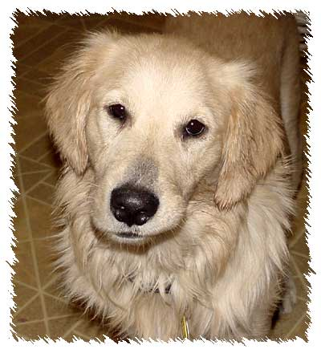

Golden Retriever Mix
Rescue
Your Address
Your Phone Number
Email

About Ruff
Ruff is a well-behaved, friendly dog enjoys the great indoors and her daily walks. She enjoys eating, playing with her toys, and using her big brown eyes to get treats from her owner. She is crate - trained and loves being in her “little house” while her owner is away. Ruff has been the beloved animal companion of Mr. Jones for seven years.
Health and Grooming
Ruff is spayed, clean and flea-free and has an ID tattoo. She loves her regular grooming and is a longtime patient of veterinarian Dr. David Zanders.
About Ruff’s Caregiver
As a responsible dog caregiver, Ruff’s owner regularly cleans and properly disposes of Ruff’s waste when they go for their daily walk. When her caregiver travels, Ruff is boarded at a professional facility, and her owner has a trusted friend to bring in the mail, water the plants, and keep an eye on the home. Mr. Jones is willing to sign a pet agreement and pay an extra security deposit for the privilege of having Ruff.
References
Their current landlord can be reached at 403.555.1234. Attached are letters of reference from former neighbors, Ruff’s boarding kennel, and health records from Ruff’s veterinarian documenting that she is spayed, current on her vaccinations, and receives regular veterinary care.
More
Ruff placed in the top five in her agility and obedience classes last year, and is very proud to show you her official ‘good dog’ certificates. Mr. Jones would be happy for a potential landlord to meet Ruff and thanks you for considering them as prospective residents of your community.

