Tigger

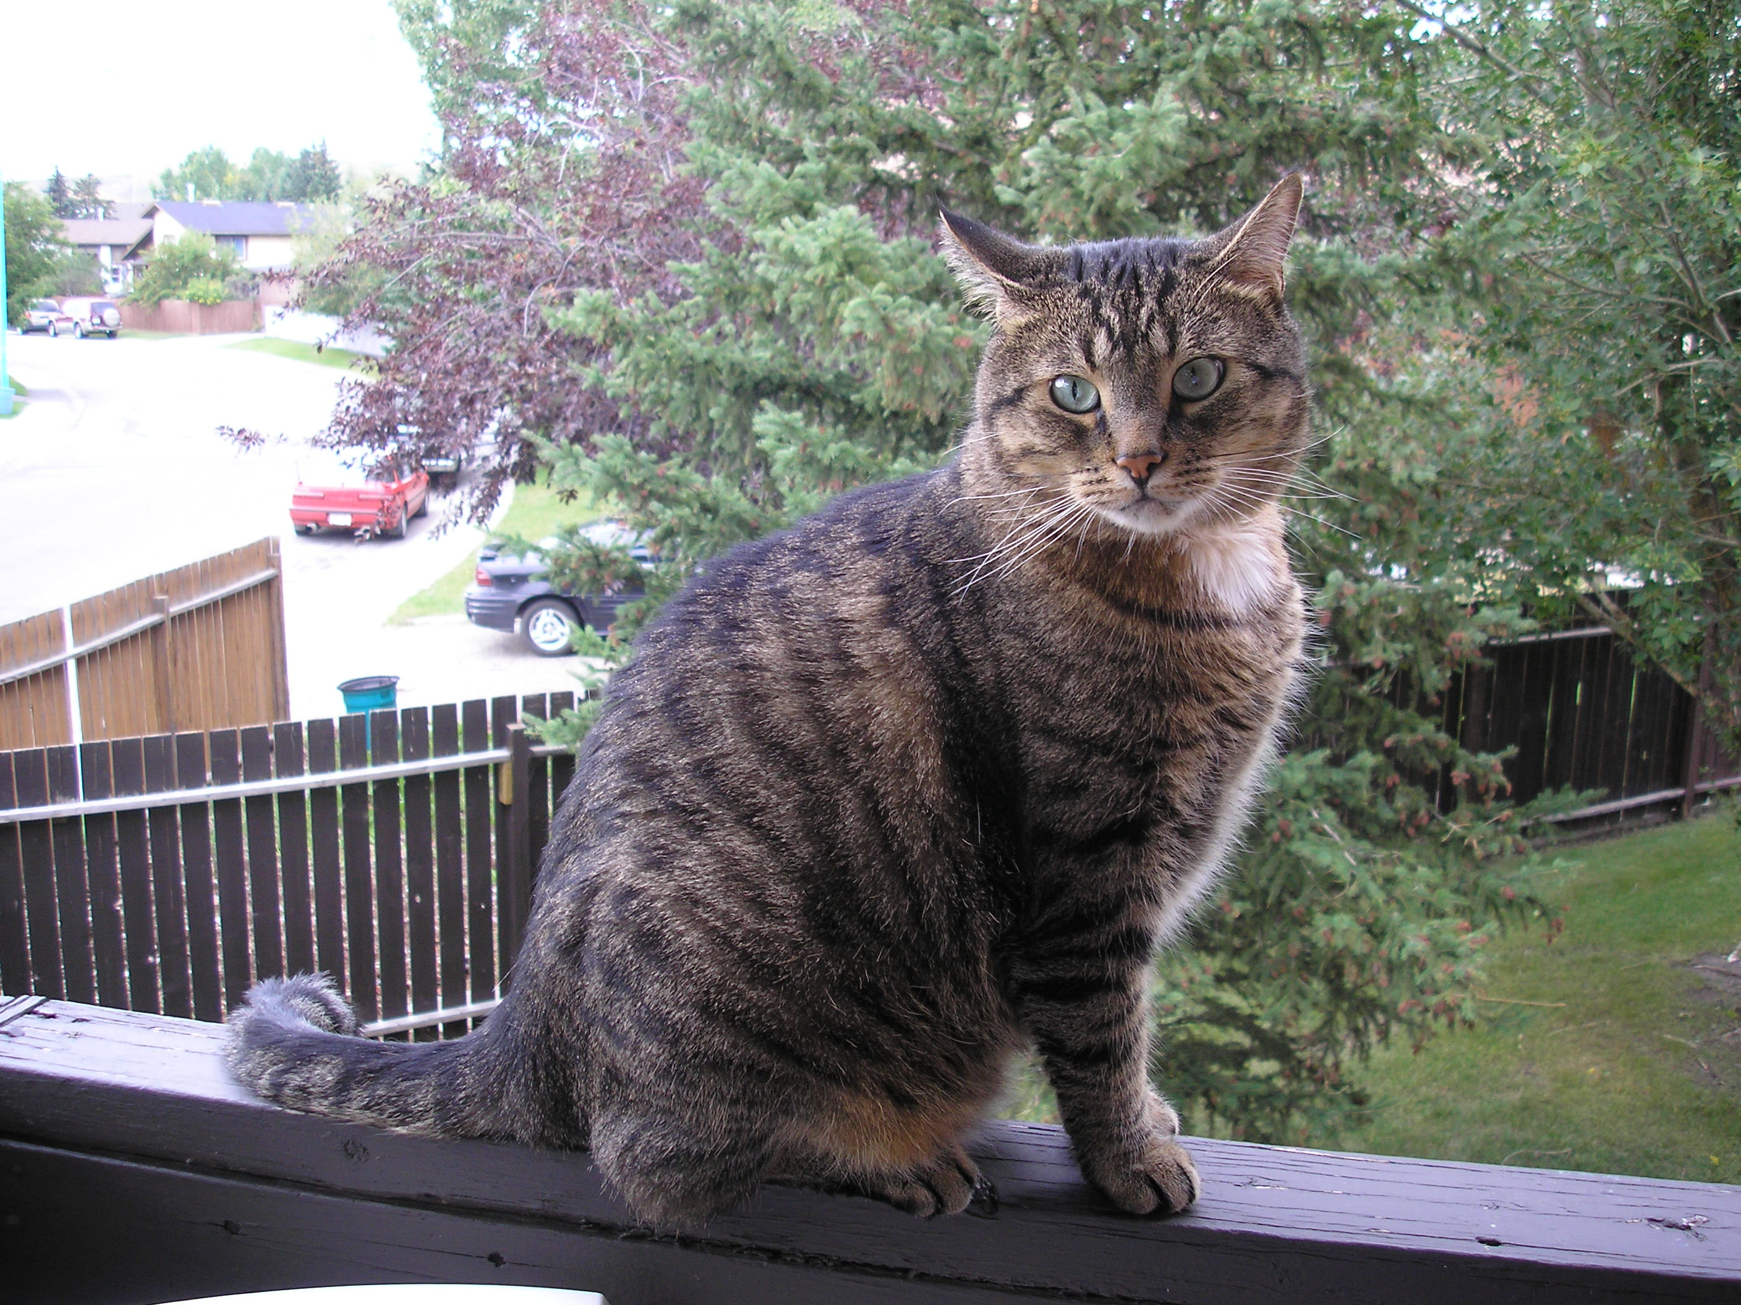

Brown Tabby – Domestic Shorthair
Rescue Cat
DOB (estimated): January 1, 2002
Your Name
Your Phone Number
Your Email Address/cell/other contact
About Oscar
Oscar is a well-behaved, friendly cat who after spending his first several years in as a feral cat now enjoys the great indoors. When he's not busy sleeping in the sun, he enjoys eating, cuddling, playing with his buddy Fitz, and being a lap cat while his owner reads. He is litter-box trained and always uses his scratching post. Tigger has been the beloved animal companion of Ms. Smith for six years.
Health and Grooming
Tigger is neutered, clean and flea-free. He loves his regular grooming and is a longtime patient of veterinarian Dr. David Zanders.
About Buddy's Caregiver
As a responsible cat caregiver, Tigger’s owner regularly cleans and properly disposes of Tigger’s litter. When his caregiver travels, Tigger is boarded at a professional facility, and his owner has a trusted friend to bring in the mail, water the plants, and keep an eye on the home. Ms. Smith is willing to sign a pet agreement and pay an extra security deposit for the privilege of having Tigger.
References
Their current landlord can be reached at 403.555.1234. Attached are letters of reference from former neighbors, Tigger’s boarding kennel, and health records from Tigger’s veterinarian documenting that he is neutered, current on his vaccinations, and receives regular veterinary care.
Ms. Smith would be happy for a potential landlord to meet Tigger and thanks you for considering them as prospective residents of your community.

