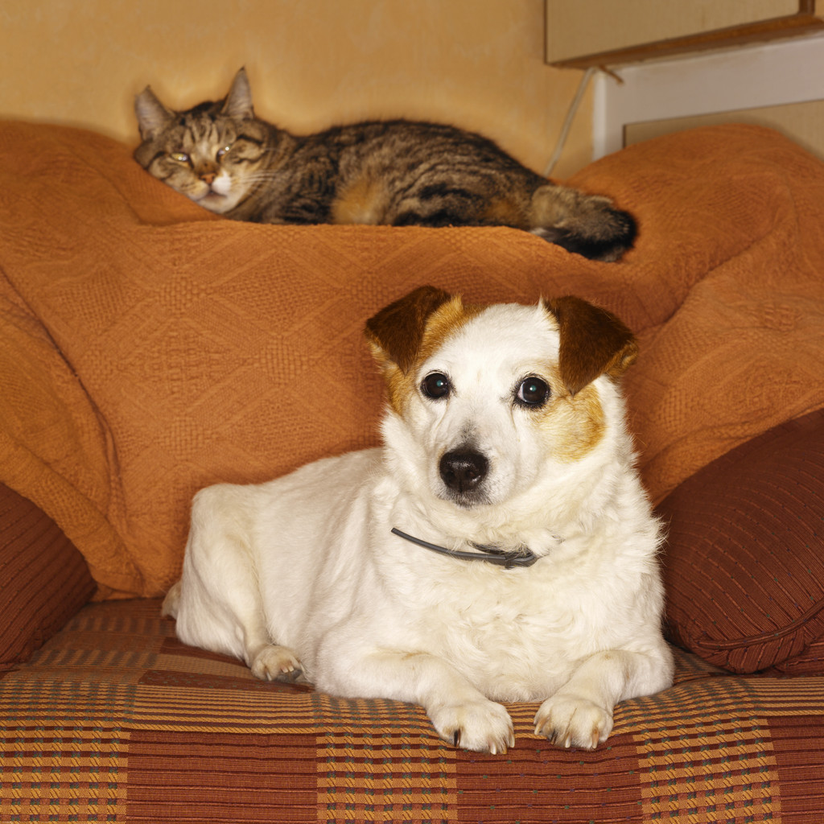

TEN COMMANDMENTS OF A RESPONSIBLE PET OWNER

- My life is likely to last 10 to 15 years. Any separation from you will be very painful.
2. Give me time to understand what you want of me.
3. Place your trust in me- it is crucial for my well-being.
4. Don't be angry with me for long, and don't lock me up for my punishment. You have your work, your friends, and your entertainment. I have only you!
5. Talk to me. Even if I don't understand your words, I understand your voice when it's speaking to me.
6. Be aware that however you treat me, I'll NEVER forget it.
7. Before you hit me, remember that I have teeth that could easily crush the bones in your hand, but I choose not to bite you.
8. Before you scold be for being lazy or uncooperative, ask yourself if something might be bothering me. Perhaps I'm not getting the right food, I've been out in the sun too long, or my heart may be getting old and weak.
9. Take care of me when I get old. You, too, will grow old.
10. Go with me on difficult journeys. Never say, "I can't bear to watch it" or, "Let it happen on my absence." Everything is easier for ME if you are there. Remember, I love you.
Author Unknown

