Exercises After Knee Replacement

Perform the exercises three times daily. Call your Physical Therapist if you have questions.

Exercises

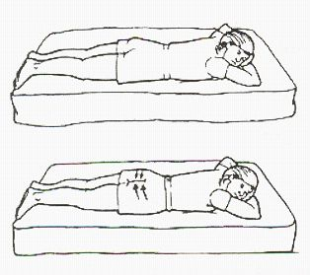

Exercise 1 of 14
Gluteal Sets
1. LIE ON BACK! (shown on stomach for visualization purposes.
2. Tighten buttocks together.
3. Hold 5 seconds, slowly relax.
4. 10 repetitions, 10 times per day.
Note: You should see your pelvis rise slightly, if doing this correctly.

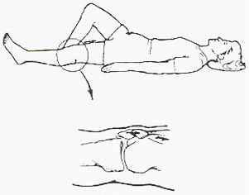

Exercise 2 of 14
Quad Sets/Extension
1. Sit or lie on your back with involved leg straight.
2. Press the back of your involved knee downward.
3. This will tighten the muscle on top of your thigh and move your knee cap as shown.
4. Hold 5 seconds.
5. 10 repetitions, 10 times a day.

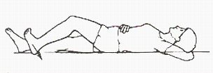

Exercise 3 of 14
Hamstring Sets
1. Lie as shown with involved knee bent partially.
2. Press heel to floor as if dragging heel towards buttocks.
3. Hold 5 seconds
4. 10 repetitions, 10 times per day.

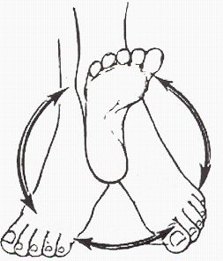

Exercise 4 of 14
Ankle Circles
1. Move your ankle around slowly in a large circle.
2. Repeat in the opposite direction.
3. 10 repetitions, 10 times per day.
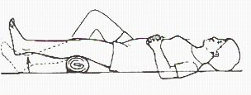

Exercise 5 of 14
Short Arc Quad/Extension
1. Lie on back with a 6 inch roll under involved knee.
2. Raise heel off floor until knee is straight, keeping back of leg pressed into the roll.
3. Hold 3 seconds and lower slowly.
4. 10 repetitions, 3-5 times a day.
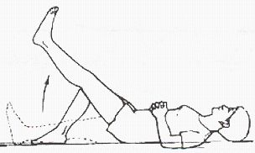

Exercise 6 of 14
Straight Leg Raise
1. Lie on back with involved knee straight and the other knee bent as shown.
2. Keep the leg completely straight, do a quad set, then raise it 12 - 18 inches.
3. Keep your knee and toes pointed toward the ceiling throughout this exercise.
4. Hold 3 seconds and slowly lower.
5. 10 repetitions, 3-5 times a day.

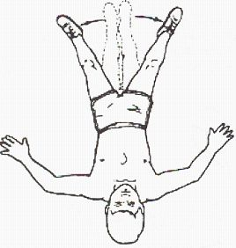

Exercise 7 of 14
Hip Abduction
1. Lie on back.
2. Slide involved leg out to the side, as far as you can.
3. Keep your knee and toes pointed toward the ceiling.
4. Hold 3 seconds, slowly return to starting position.
5. 10 repetitions, 3-5 times a day.
6. When this exercise becomes easy, do #8 instead.

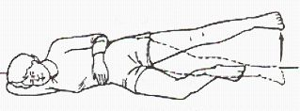

Exercise 8 of 14
Hip Abduction
1. Lie on side with involved leg on top.
2. Bend lower leg slightly, for support.
3. Raise top leg straight up, without letting it come forward.
4. Keep your toes pointed forward.
5. 10 repetitions, 3-5 times a day.
6. Do not do this exercise until you can do #7 easily.

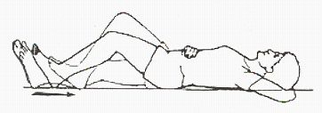

Exercise 9 of 14
Knee Flexion
1. Lie on bed or table as shown.
2. Slide your involved heel up toward your buttocks bending your knee until you feel a stretch.
3. Hold 10 seconds.
4. 3-5 repetitions, 3-5 times a day.

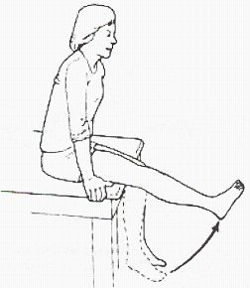
Exercise 10 of 14
Quadriceps/Extension
1. Sit on edge of table or bed.
2. Straighten knee fully.
3. Hold 3 seconds and slowly lower.
4. 10 repetitions, 3-5 times a day.

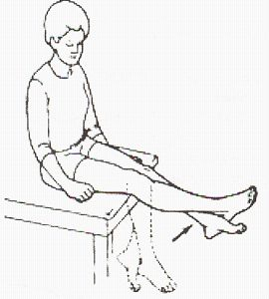
Exercise 11 of 14
Quadriceps - Assisted
1. Sit on edge of table or bed.
2. Straighten involved knee with assistance of other leg. Hold for 20-30 seconds each time.
3. Then slowly lower leg, assisting with other leg as needed. Hold for 20 - 30 seconds each time.
4. Try to do as much of the work with the involved leg as possible.
5. 5 repetitions, 4-5 times a day.

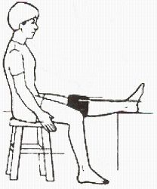
Exercise 12 of 14
Knee Extension
1. Place less than 5 lb. weight around knee.
2. Sit with leg propped as shown.
3. Relax, letting the leg straighten. If you can, push downward above the knee to create a greater stretch in the back of your knee. It is very important that you work to get your knee as straight as possible.
4. Hold 30 - 60 seconds.
5. 5 repetitions, 4-5 times a day.
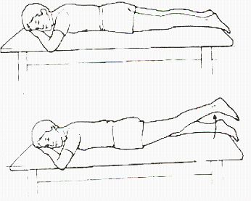
Exercise 13 of 14
Hip Extension
1. Lie on Belly.
2. Raise involved leg off floor as shown.
3. Hold 3 seconds, slowly relax.
4. 10 repetitions, 3-5 times a day.
5. If you cannot lie on your stomach, you can do this exercise standing up.
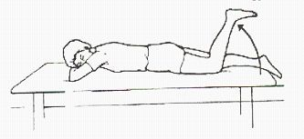

Exercise 14 of 14
Hamstring/Flexion
1. Lie as shown.
2. Slowly bend involved knee.
3. Hold 3 seconds and slowly lower.
4. 10 repetitions, 3-5 times a day.
5. If you cannot lie on your stomach, do this exercise standing up instead.

