Oscar

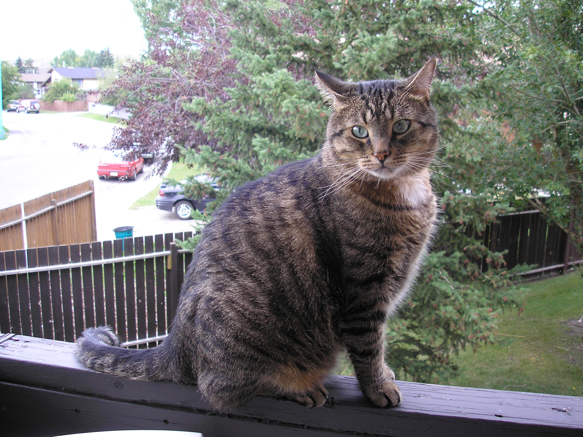

Brown Tabby – Domestic Shorthair
Rescue Cat
DOB (estimated): January 1, 2002
Rescue
Address
Phone Number
Email

Important Information:

Is not destructive
Friendly
Neutered
Completely house trained
Tattooed
Up to date on all shots
Completely litter trained
Indoor only – supervised on balcony

References of Previous Landlords:

References

Dr. Rick Dalrymple, Big Hill Veterinary Services

D.V. (reference for behvaiour – she has visited and met Oscar)

D.E. (reference for behvaiour – she has visited and met Oscar)

A Purrfect Place Cat Boarding – (Oscar has boarded there many times)

