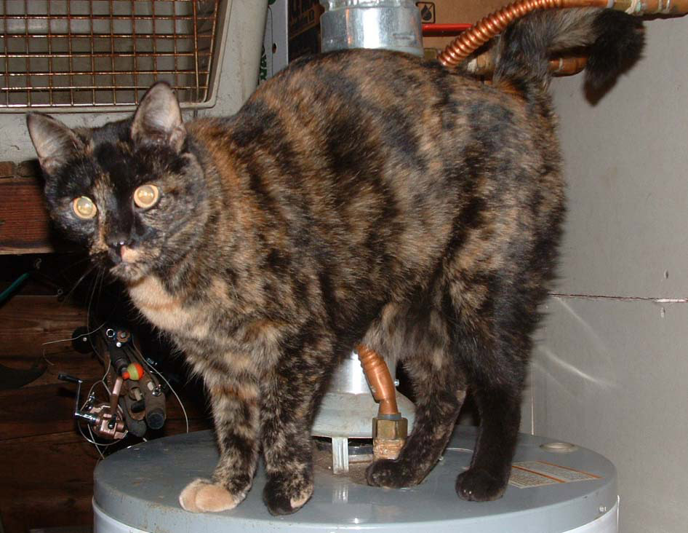

I’m Bree

I am approximately 9 years old and am very affectionate! I love to cuddle and give kisses. I don’t mind children or other pets, as long as they’re nice to me. I am a special needs kitty…I have a condition called Urinary Track Disease, which I contracted having been out in the wild for so long. Luckily, all this means is that I need special food to keep my system happy. (I come with a free bag of food!!!) I would love to be your new companion!

