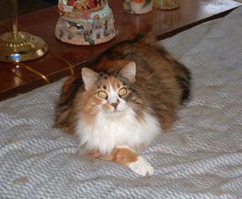

I’m Jazz

I’m 6-7 years old and love affection. I prefer homes with no other cats, but I will tolerate one or two once I’m used to them. I will also tolerate dogs as long as they leave me alone. I don’t mind children, but I prefer adults. However, I’m really not suited for homes with small children. I can be very affectionate, but I prefer not being held; though don’t be surprised if I decide to jump up in your lap periodically. I know I sound a bit “high maintenance” but I’ve heard that I’m really an awesome cat. I’ll even chat with you at times…when I have things to say anyway. I would love to become a part of your family and promise to be a wonderful companion!

