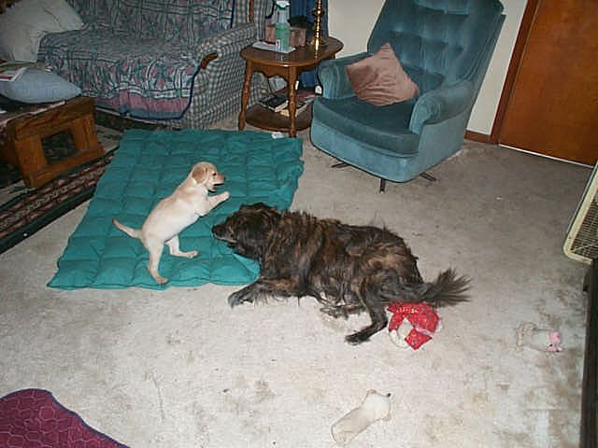

Fly through the air!….It’s…it’s…SUPER PUPPY!!

Somewhere…out there..
is a sleeping big sister….
just fair game for SUPER PUPPY.!!

